**Major project**

**Cmd > npm init**

**Cmd > npm i express**

**Cmd > npm i ejs**

**Cmd > npm i mongoose**

**Cmd > npm i method-override**

Now create app.js

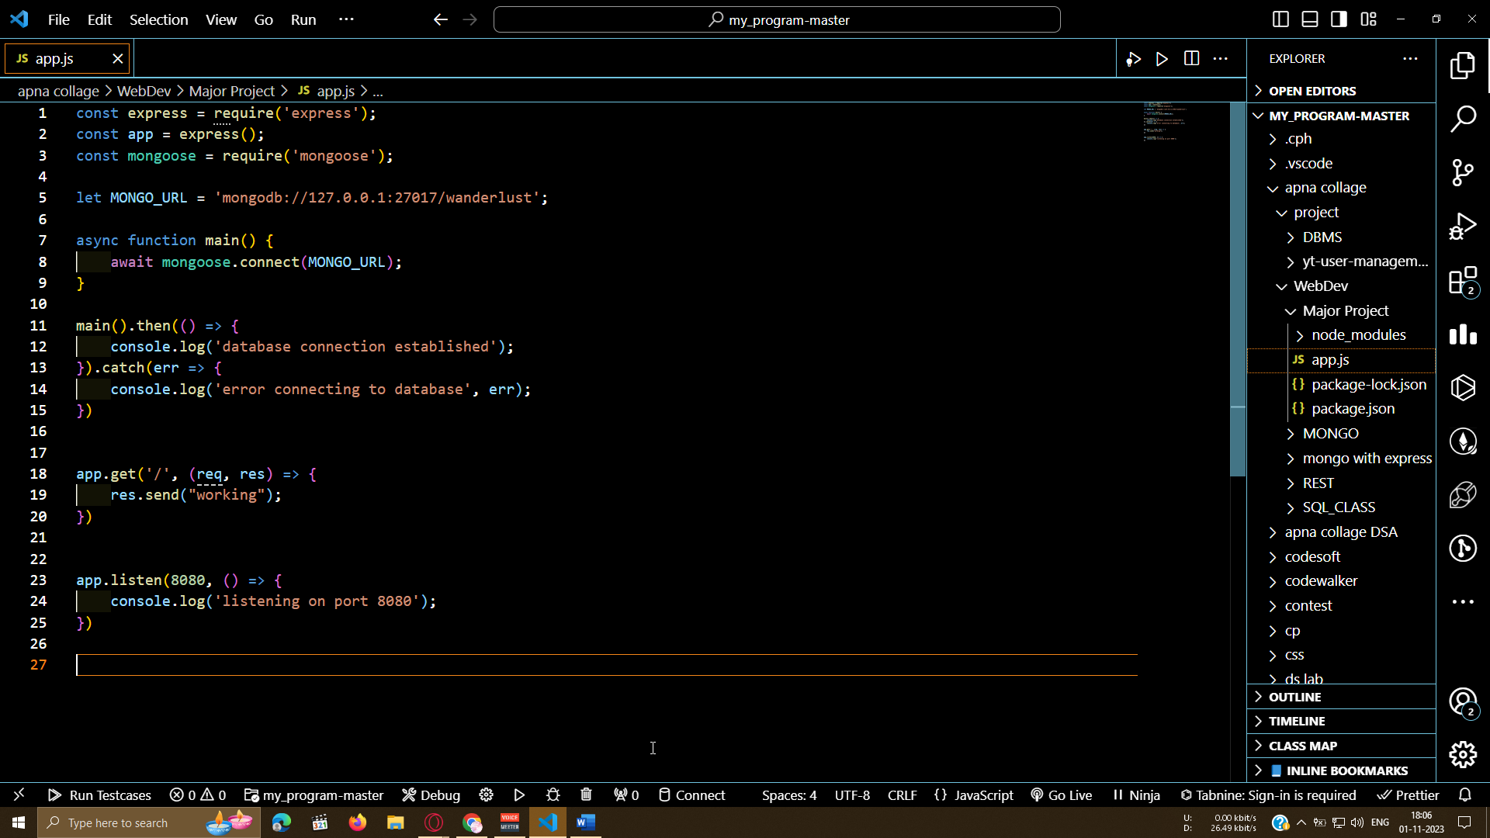

**.**

**Now**

.

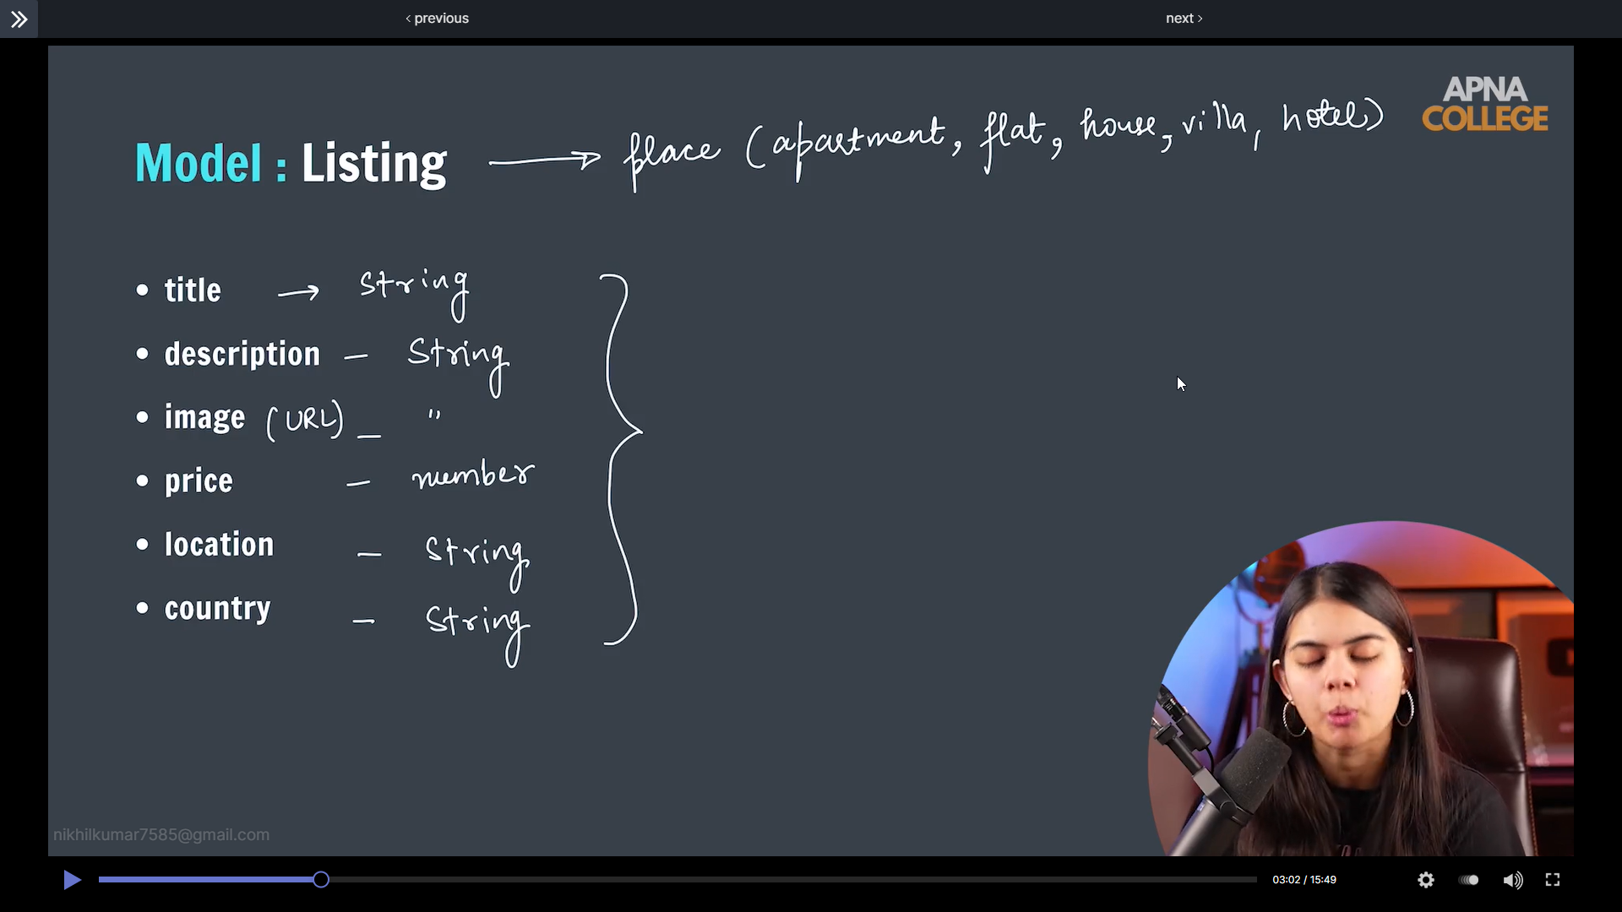

New create folder name models and create file listing.js

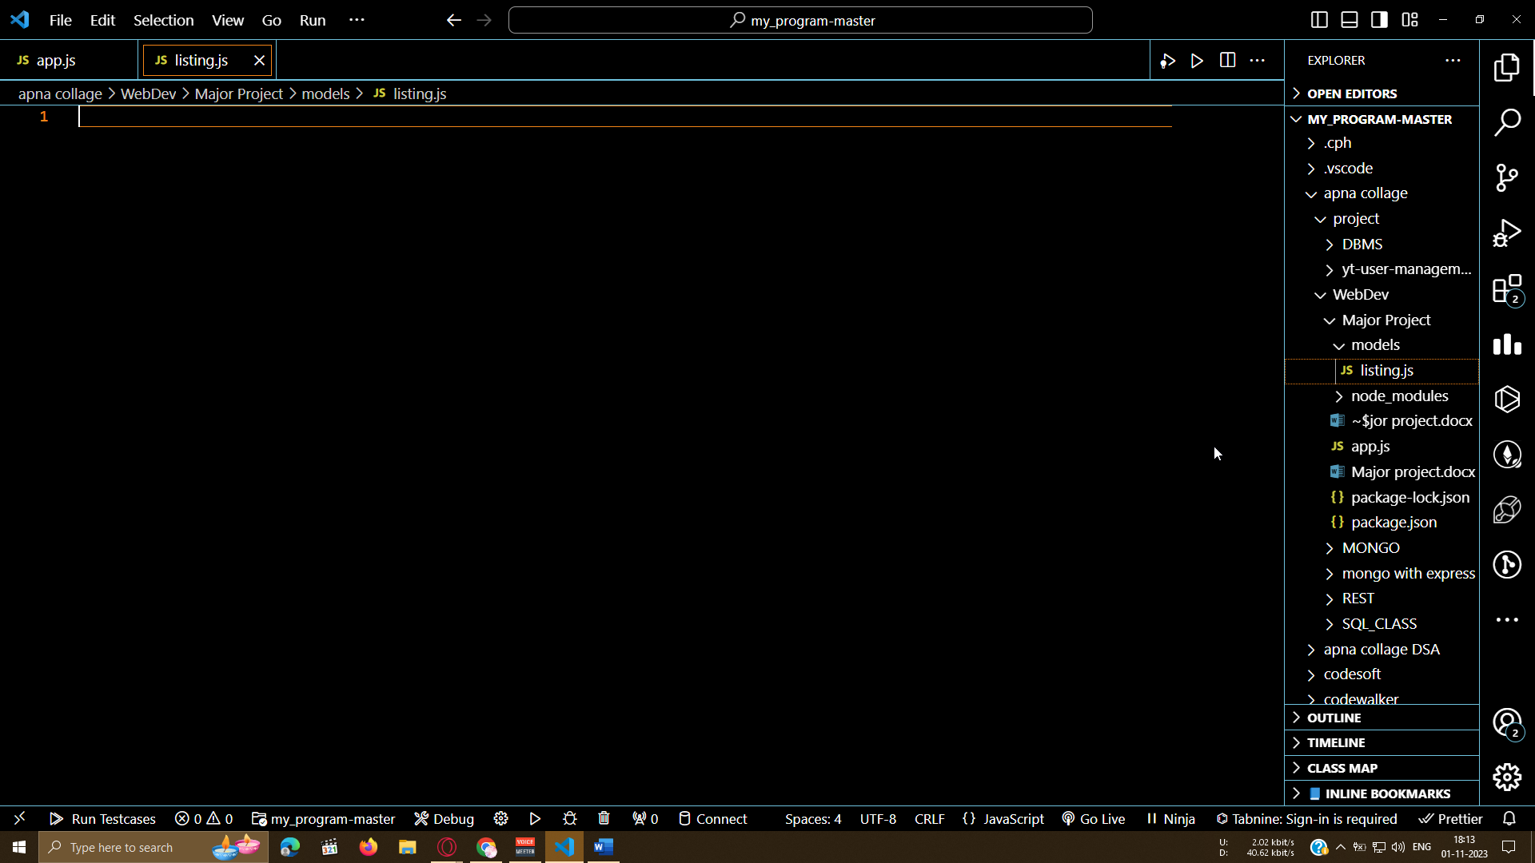

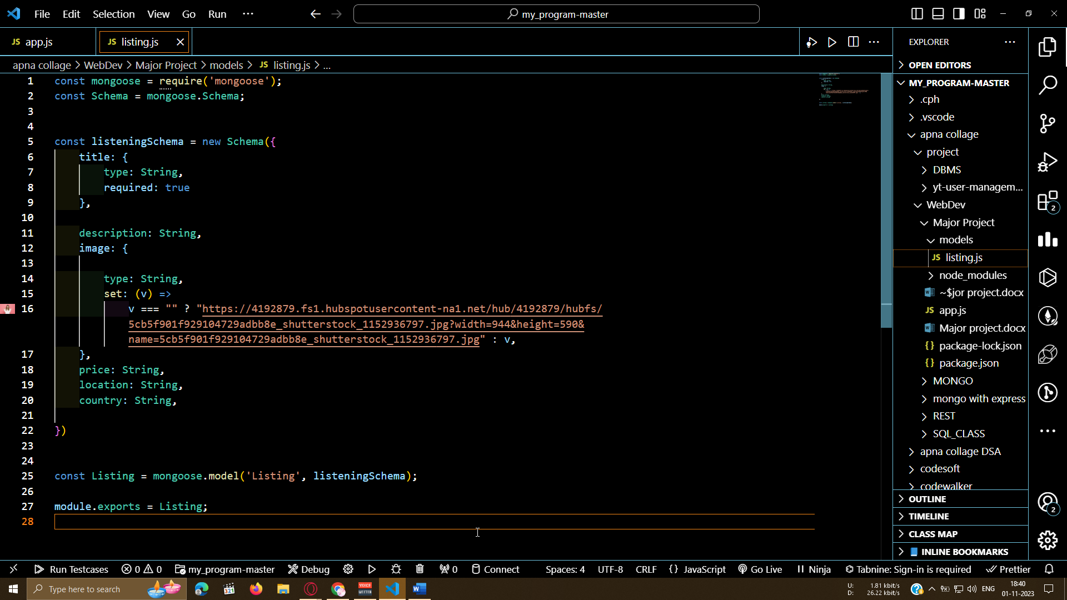

Listing .js

const mongoose = require('mongoose');

const Schema = mongoose.Schema;

const listeningSchema = new Schema({

    title: {

        type: String,

        required: true

    },

    description: String,

    image: {

        type: String,

        default: 'https://4192879.fs1.hubspotusercontent-na1.net/hub/4192879/hubfs/5cb5f901f929104729adbb8e_shutterstock_1152936797.jpg?width=944&height=590&name=5cb5f901f929104729adbb8e_shutterstock_1152936797.jpg',

        set: (v) =>

            v === "" ? "https://4192879.fs1.hubspotusercontent-na1.net/hub/4192879/hubfs/5cb5f901f929104729adbb8e_shutterstock_1152936797.jpg?width=944&height=590&name=5cb5f901f929104729adbb8e_shutterstock_1152936797.jpg" : v,

    },

    price: String,

    location: String,

    country: String,

})

const Listing = mongoose.model('Listing', listeningSchema);

module.exports = Listing;

app.js

const Listing = require("./models/listing.js");

app.get('/testlisting', async (req, res) => {

    let sampleListing = new Listing({

        title: 'My New Villa',

        description: 'By the Beach',

        price: 1200,

        location: 'calangute, Goa',

        country: 'India',

    });

    await sampleListing.save();

    console.log("Updated");

    res.send("succesfully updated");

});